Final Project Report of Blackjack

netId: kz2193, name: Kexin Zhou

This game is so charming all over the world. It is because the rules are simple and to win the game players have to be both cautious and risky.

1. Rules of Blackjack is very brief:

* 52 cards will be randomly shuffled (without jokers), player will get 2 initial cards and they could decide to hit(get one card more) or stand(stop getting card) according to the cards in their hand
* Blackjack = A +J/Q/K
* Each player only competes against dealer using the sum value of cards in their hand
* When player got blackjack, that player win the game, but if dealer also get blackjack they are tie
* J/Q/K are regarded as value: 10
* Core of the game: If cards’ sum value exceed 21, player or dealer immediately lose the game. Hence, players should be careful to hit more cards in order to beat dealer and also keep the sum value under 21.

1. Plan to do:

* Network for players to get connected with server and exchange data:

Allow three players join and play in the game simultaneously.

* Multithread and synchronize:

Dealer could serve for players with multithread and synchronize the shared cards box while getting cards.

* GUI:

Allow players to join and play in the game with ease

Allow programmer to supervise the process of the game.

1. Achieved Function:

* Method for Players:
  + Join and start the game
  + Hit card (get more cards) and stand (stop getting cards)
  + Send the action signal to dealer (signal=1: start and initial cards, 2: hit,3: stand)
  + Reveal their own hand cards as well as other players’ initial cards and dealer’s visible card
  + Analyze and record the status of players and dealer(start, playing or finish)
  + Judge (compare the sum value of handcards) the result of the game according to handcard of players and dealer
  + Reveal all of the players’ as well as dealer’s result of game, including win, lose, tie and blackjack.
  + Record and reveal the accumulated points to players
  + Restart the game (play again)
* Method for Dealer:
  + Get and process the action signal from players
  + Get card (randomly get one cards from card box) and also synchronize the cards in box(haven’t been used)
  + Send cards to players and self
  + Analyze and record the status of players and dealer
  + Print out dealer and players’ operation on the sever window

1. Instruction of running the game
2. Click ‘Run’ server.java to boot the game server
3. Then run clientJoin.java (Since only when 3 players join the game, server would start, hence, we need to run clientJoin.java three times to act as three players), see the window like this:

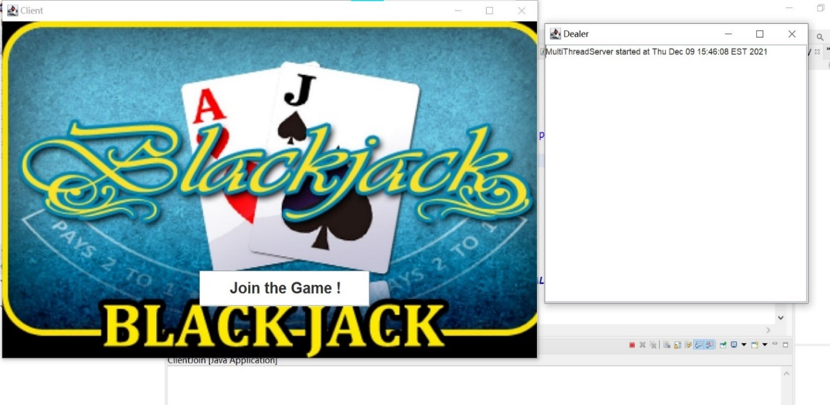

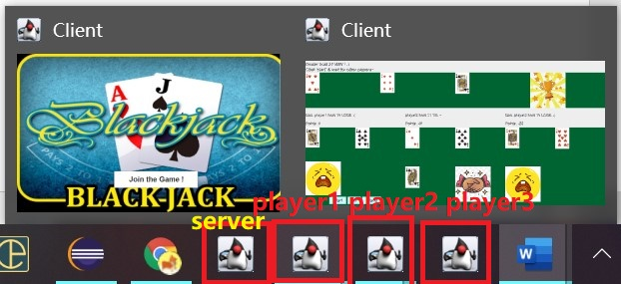

Four Windows in total: Server, player1, player2, player3

1. Click ‘Join the Game!’ button on three client windows separately to join the game:

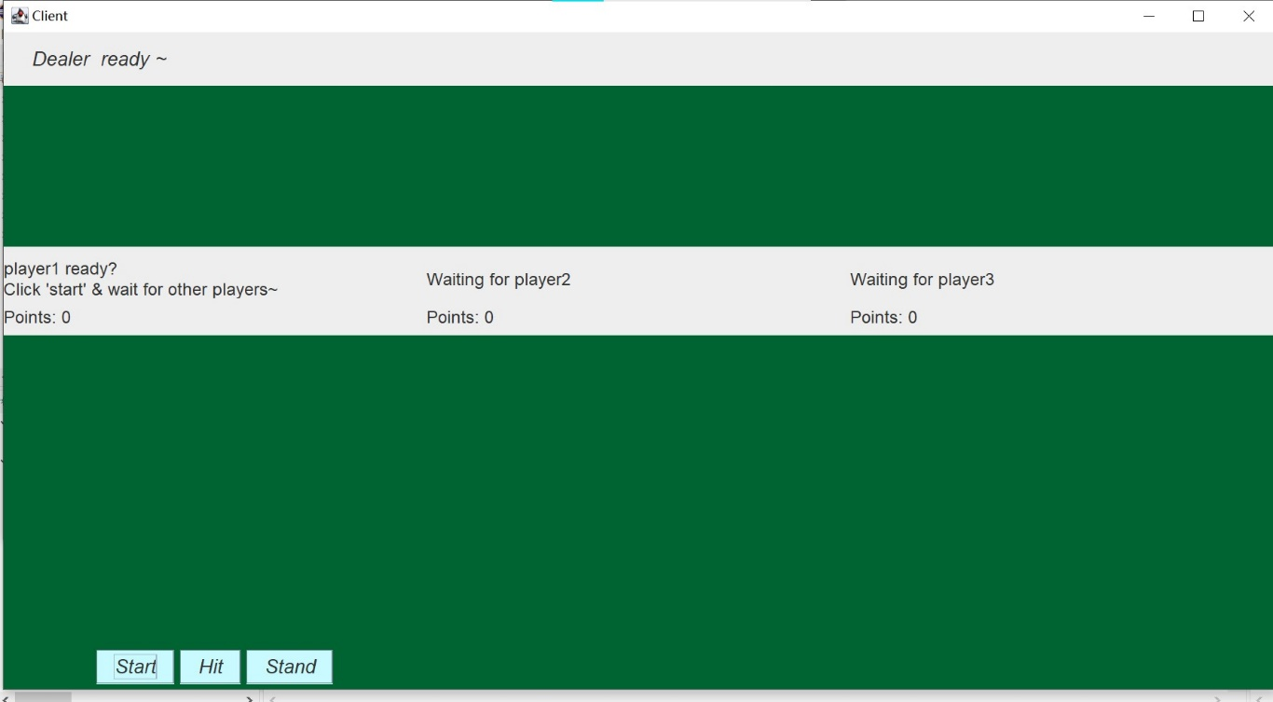

1. Then click ‘Start’ in three client windows separately. (act as 3 players)

When 3 players all Start the game, server will send 2 initial cards to each player and dealer, but only one card of dealer could be seen and 4 initial cards of other players are also visible. Like this:

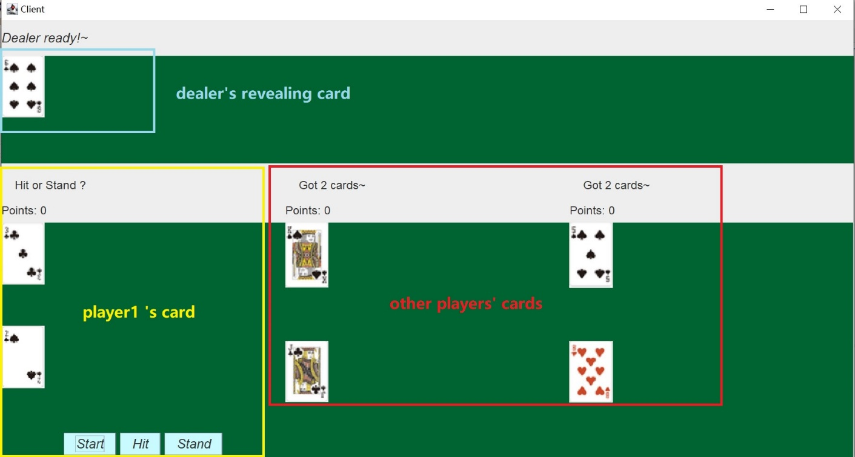

1. Then player could decide to hit or stand? After player1 hit:

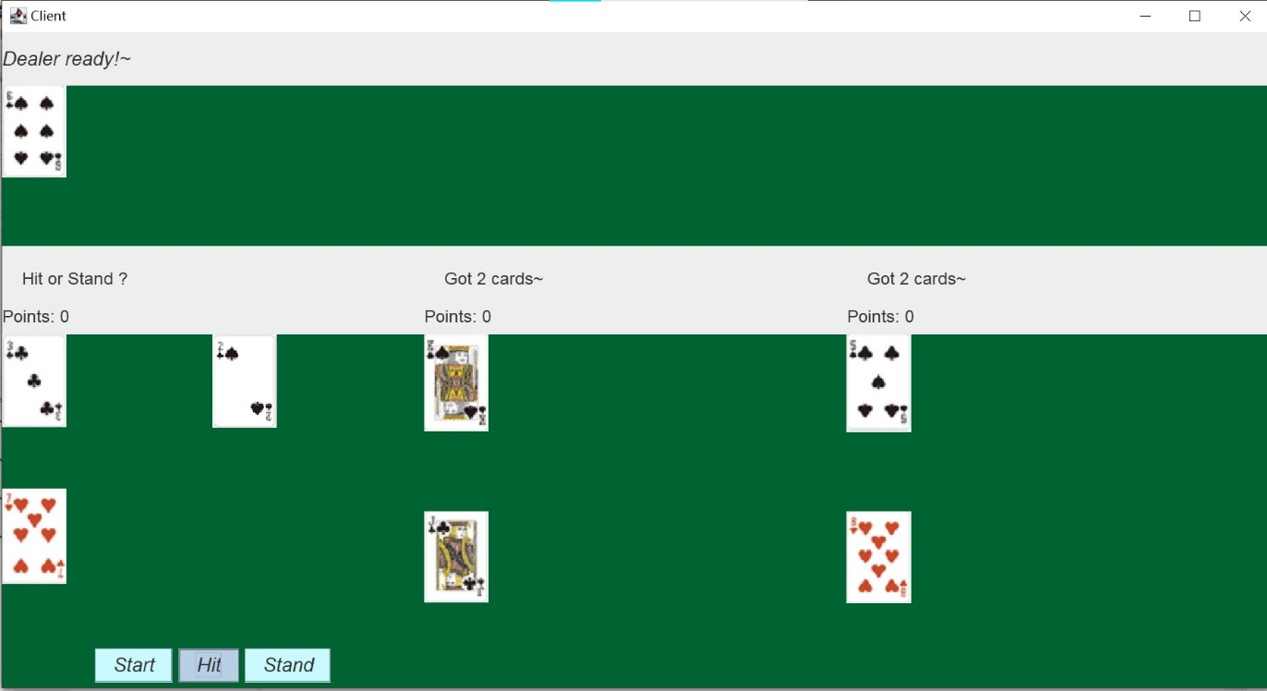

Player could randomly get more cards from server, but when the Hit button never rebound(like the one in the above picture), it means that player couldn’t hit more cards(it actually indicates that player already bust). Then player1 finish dealing and could just wait for other player finish dealing and after that the result will be revealed.

Player2 got 2 cards(value: 20) which approaches to 21! Thus, the wise choice for player2 is to click ‘Stand’ to finish dealing and wait for other player done. Like this:

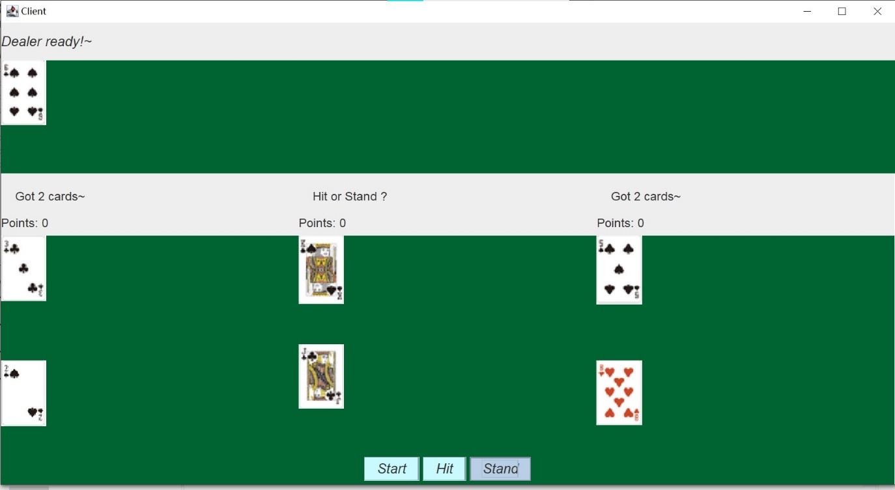

1. When all of the three players finish dealing, dealer will get cards and decide hit or stand by program automatically. When the total value of cards beyond 17, dealer stop hitting and compare the value of cards with 3 players and give them result of the game. If dealer BUST, dealer immediately lose the game. But if player BUST first, dealer immediately win the game.
2. Result like this:

In player1’s aspect: dealer only compare cards with player1 and the result only depend on hand cards in dealer and player1

so player1 BUST and Dealer win the game

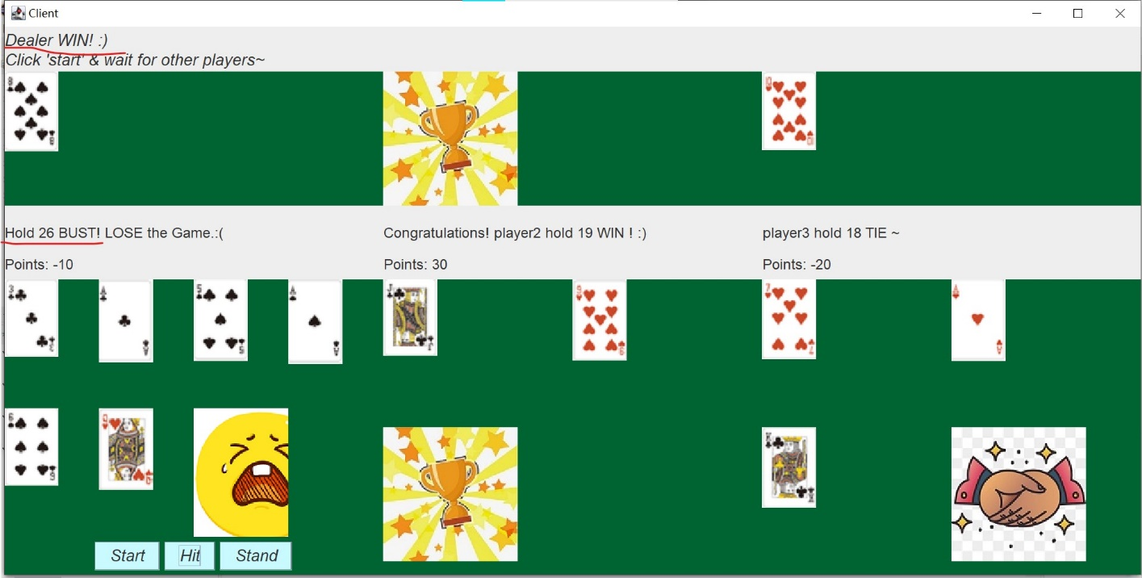

In player2 aspect: value of cards player2 (19)> dealer (18), hence player2 beat dealer.

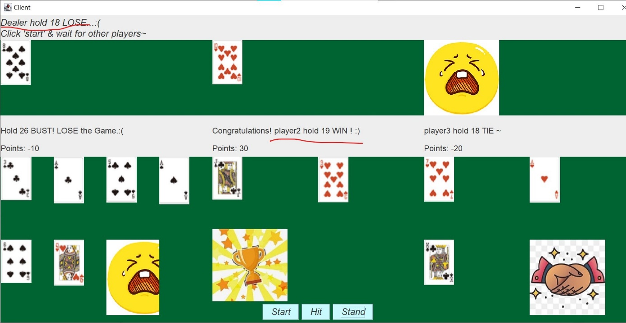

In player3’s aspect: player3 and dealer have the same value so they tie

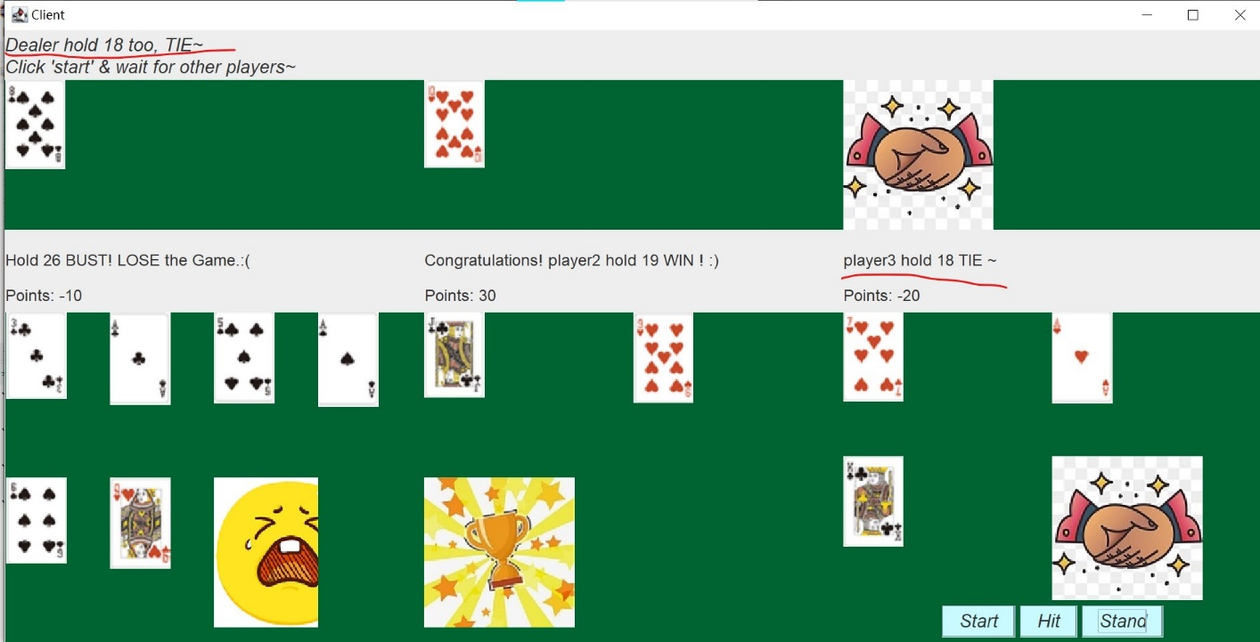

Each player could see other players’ initial cards at the beginning and result at the end.

More Result: player1 got black jack!

Since dealer didn’t get blackjack , player1 immediately win!

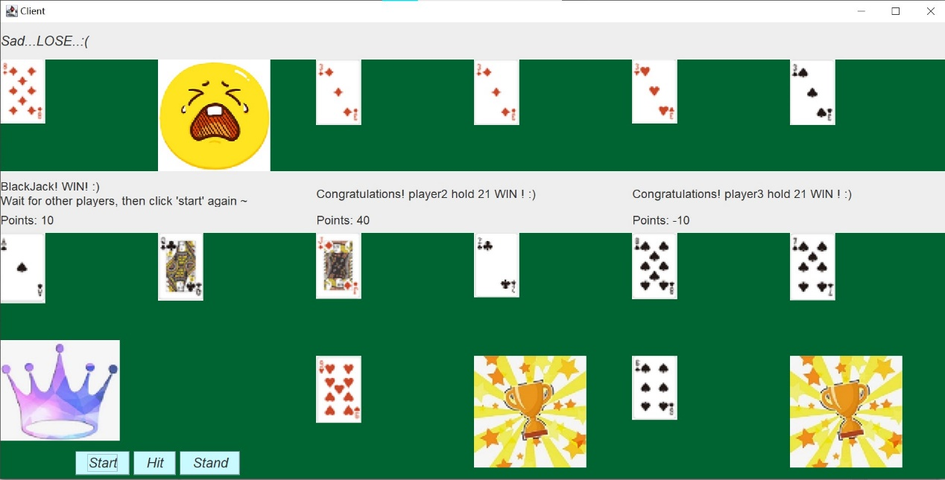

When dealer got blackjack, as long as player doesn’t get blackjack, they lose:

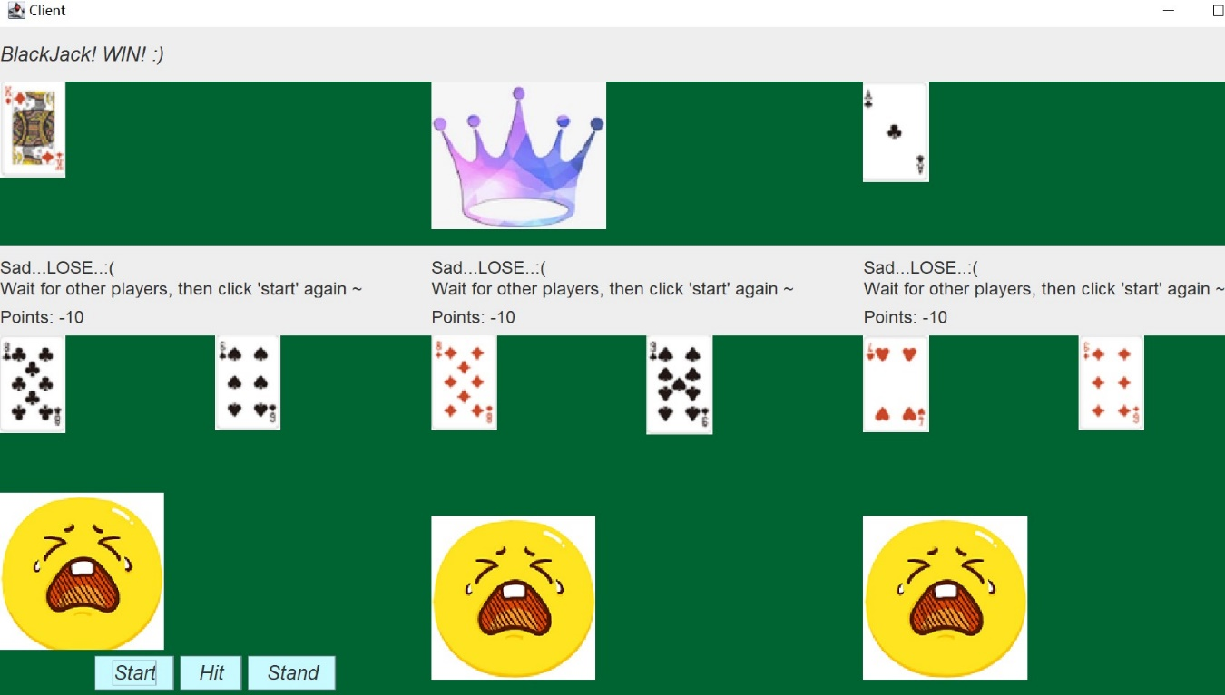

After seeing all of the three players’ results (all have done), player could click ‘Start’ and wait. When 3 players all decide to Start, they will start a new game. And their points could be accumulated. As we can see in the client window.

